TIDDINGTON 4 VILLAGE PLAN | 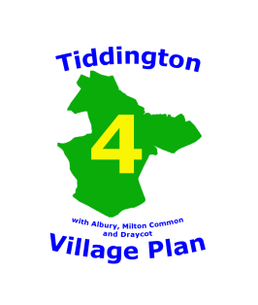

Your Collector will be ...................................................................

Your Collection date is ......................................in the ....................................

Your response to this questionnaire is important, because:
- It helps our parish, district and county councils to understand what we as a parish want and do not want

- It therefore advises and helps guide the council policies that affect us

- It helps to raise money, through grant applications made by the parish council, as evidence of support for the specific proposal or development

- The higher the response rate the stronger the evidence of local support for or opposition to proposals and plans, so making our Village Plan more effective

All responses are anonymous

- The subjects addressed are those that previous, informal consultations in the parish have shown to be of importance to us all

- The questionnaire seeks views and tests opinions; it does not direct or prescribe

- Immediate action on a particular point may not be possible, but the thinking and action of those responsible will be influenced as and when appropriate

Everyone completing a questionnaire will be entered into a prize draw, with a single prize of £100, provided you complete the separate sheet containing your name and contact details

Instructions for Completing the Questionnaire

Please complete one questionnaire per person

Please use a black or blue pen to tick boxes or write text

If you make an error in ticking a box please black out the box completely and then tick the box or boxes you wished to use

Should you require a further copy of the questionnaire or further information about the village plan this can be obtained from the Tiddington 4 Village Plan website using this link www.tiddington4villageplan.co.uk

Should you require any assistance with completing the questionnaire please contact either:

Your collector on ..................................................

or

Nigel Draper, Steering Group secretary on 01844 339 347

